School of Engineering, Science and Technology

Universidad del Rosario

Carrera 6 # 12C-16 Of. 506

Bogotá

COLOMBIA

Email: edgar.andrade@urosario.edu.co

Emily Chenette

Deputy Editor-in-Chief

PLOS ONE

Dear Mrs. Chenette:

We wish to submit the manuscript **Self-Organized Division of Cognitive Labor** for consideration for publication in the ResearchArticle section of PLoS ONE.

We have carried out research studying how individuals in a group can divide the group’s task and have observed that efficient solutions can often emerge when iterated interactions elicit and consolidate individuals’ biases toward particular divisions. Our target phenomenon is sufficiently general that it can be observed in a wide range of situations from the emergence of well-defined roles in scientific collaborations to the establishment of divisions within a company, and we feel that our findings have the potential to complement well-established theories on the topic of group cooperation, such as Schelling’s focal points approach. We believe that our paper would be of interest to a large audience of Cognition readers including computer scientists, psychologists, economists, sociologists, and management scientists.

The manuscript has been approved by all of the Authors, it has not been published or accepted for publication, and is not under consideration at any another journal.

Our nominee from the Academic Editors is Nicholas D. Duran, Christopher M. Danforth, Micah B. Goldwater, Roxanna Morote Rios, Alexandra Paxton, David Keisuke Sewell, Jan De Houwer, and John D. Coley.

Yours sincerely,

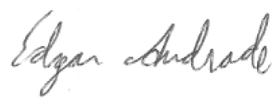

Edgar Andrade-Lotero (corresponding author)